INFS 774 Big Data Analytics
Assignment 3
Due: 7/2/2020 + one-week grace period

Please finish three tasks (Q1, Q2, and Q3) below. Please read the Common Errors section, if you encounter any problem. Quite possibly you can your answers there.
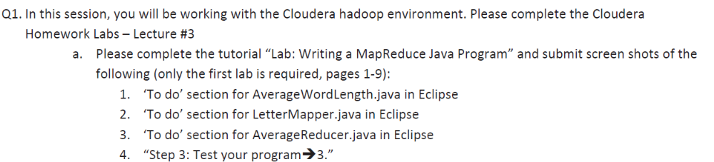
For 1, 2, and 3, you can submit a screenshot of the code; or you can submit the java code directly if you have trouble doing the screenshot.
For 4. Results of Step 3.3 on page 8. You need to type hadoop fs -cat wordlengths/* and do a screenshot of the results.
I think you should definitely try the second lab, but you don't need to submit anything.
Lab 3 "writing a MapReduce Streaming Program" is quite useful. Some of you may not be familiar with Java, the native language of Hadoop, but know other languages such as Python, Perl, Ruby, etc well. It's possible to write MapReduce code using these languages. Let's say you want use Python to write mapreduce code. You have two options. The first option is to write a streaming program in Python according to the instructions in the third lab. The second option is use Pydoop, a python interface to Hadoop. You are encouraged but not required to do this lab.
Lab 4 is about conducting unit tests, which is extremely important for Hadoop programming since it's very difficult to debug in the Hadoop environment. https://cwiki.apache.org/confluence/display/MRUNIT/MRUnit+Tutorial provides useful sample code for doing unit test. Please try this lab.
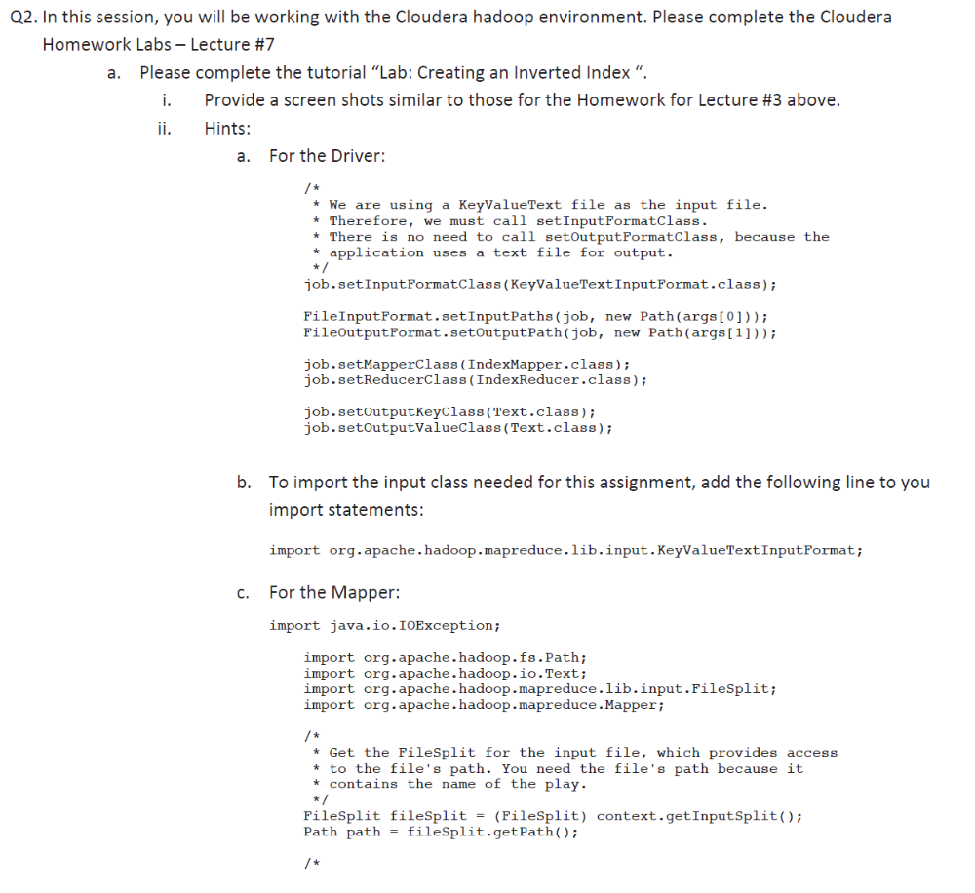
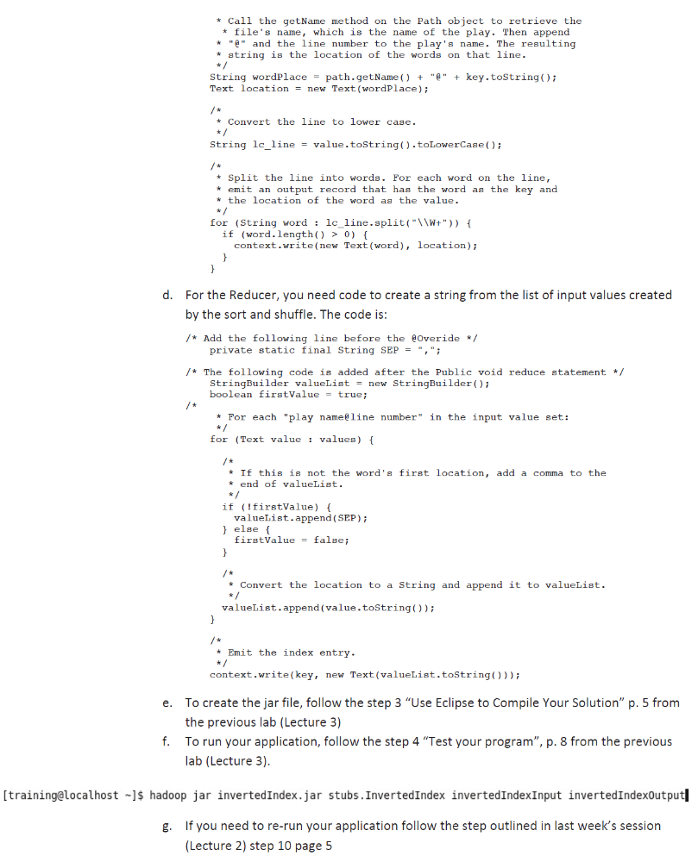
For Lec 7 lab (Q2), you need to submit:
1. The java code "InvertedIndex.java" or a screenshot of the code (just show me the run method. You can remove the comments when you make the screenshot )
2. The java code "IndexMapper.java" or a screenshot of the "map" method in the code.
3. The java code "IndexReduce.java" or a screenshot of the "reduce" method in the code.
4. The screenshot of the results (I just need to see the first 3 lines of the results. you can do the following):
hadoop fs -cat invertedIndexOutput/* | head -n 3
invertedIndexOutput is the output folder name.
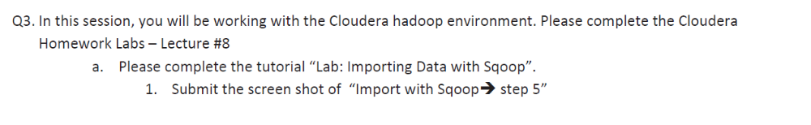
Common Errors:
- NameNode in safe mode error: If you see this error, please try "hdfs dfsadmin -safemode leave"
- Assignment 3 - "output directory not set": In lab 3, you need to work on three files including AverageReducer.java, LetterMap.java, and AvgWordLength.java. You need to write some java code. Primarily you need to copy the code from the wordcount project and modify the code a little. If you create the jar file without implementing the three java classes, you will see the "output directory not set" error.
- Assignment 3 - file/path does not exist error: Whenever you see a input file (or path) does not exist error, you want to first make sure you have already uploaded your input dataset. If you are quite sure that you have uploaded the dataset (i.e., you can see the dataset by doing hadoop fs -ls) and you still have such an error, then it is possible that you have uploaded the dataset more than once. I have discussed this error previous in assignment 2. The cause of the issue is that Hadoop does not allow us to overwrite a dataset. So if we upload the input dataset more than once, you will see the file/path not exist error. How to deal with the issue? For the input dataset not exist error, remove and re-upload the input dataset.
- Assignment 3 - Error opening jar: You need to make sure that you are running the code where the jar file is located. Let’s say the jar file you created is in the folder /home/training. You need to go to /home/training to wrong the jar code.
If you really don’t know how to solve the issue, you first cd ~/workspace/averagewordlength/src then use the javac command you used in assignment 2 to manually compile these files, and then use the jar cvf comman to construct the jar file manually.
- Assignment 3 - output directory already exist error: When you see this error, please remove the output directory and re-run your code. The reason is that hadoop does not allow us to overwrite an existing dataset.
- Assignment 3 - XMLJAXBElementProvider$Text: When you see this error, please refer to http://unmeshasreeveni.blogspot.com/2014/04/wrong-import-statements-in-hadoop.html
- Assignment 3 cannot resolve type error: Whenever you see this error, quite possibly, it means a data type hasn't been imported. You can click the error icon (little red "x") and click import .... Eclipse is a very nice tool. It provides hints for resolving errors.

